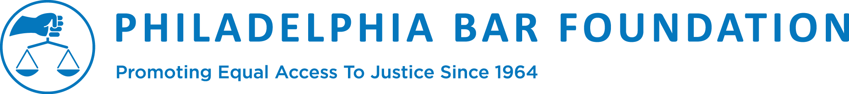

Operations & Technology Administrative Intern

CONTACT: Cecelia Driscoll, Administrative Assistant
215-238-6337, cdriscoll@philabarfoundation.org

Through programs, grants, and partnerships, the Philadelphia Bar Foundation removes barriers to justice, engages the community in support of civil legal aid, and builds system-wide capacity in order to strengthen the provision of quality legal services and to ensure that all individuals understand their rights to equal justice under law. Our Foundation works with various stakeholders in the private bar, the business community and the legal aid community to advance our mission. We are looking for someone who thrives in a team environment, and has flexibility to adapt to different tasks required for this role.

TRANSPORTATION STIPEND IS AVAILABLE. Hours are flexible and may be dependent on university internship program requirements and scheduling.

A highly qualified individual for this position will have the following credentials:
- Currently attending college or a college graduate living in the Philadelphia area
- Interest in expanding skills in administration, database management and operations
- Excellent skills for oral and written communication and stakeholder relations
- Proficient with the full suite of Microsoft Office products and a willingness and demonstrated ability to quickly learn new technology
- Proficient Salesforce experience strongly preferred
- Highly organized with strong attention to detail and accuracy and aptitude for time management among multiple high-priority tasks
- High energy, outgoing, team player, and a passion for the Foundation’s mission

Responsibilities:
- Assist with administration and review of the Foundation’s processes and standards
- Prepare information for materials and reports as requested by Foundation staff
- Perform tasks related to database management, research, compilation, and analysis of data

