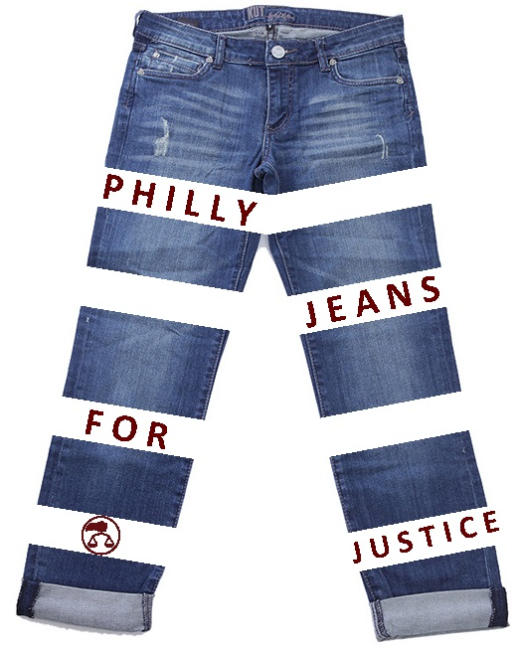
2017 Philly Jeans for Justice Campaign FAQ
Q: What is Philly Jeans for Justice?
A: Philly Jeans for Justice is a fun way for law firms, legal departments, and other businesses to raise crucial funding to support the Philadelphia Bar Foundation and its grants and other assistance to a wide range of legal aid nonprofits. Our mission:
The Philadelphia Bar Foundation is dedicated to promoting access to justice for all people in the community, particularly those struggling with poverty, abuse and discrimination. The Bar Foundation is the embodiment of the Philadelphia legal community’s commitment to this fundamental principle. We accomplish this mission by providing grants and technical assistance in support of quality legal services, addressing unmet legal needs and providing education on matters in the public interest.
Q: When does this take place?
A: Every month in 2017 – You pick the day! Pick a day during the year that works well for your office, through December 31 when the competition closes.
Q: What is involved for participating in the event?
A: People at your law firm, legal department, or law-related business “buy” the privilege to wear blue jeans (or skirts) at work for one day. Or your office team can decide to wear sports jerseys, hats from your alma mater, Halloween costumes, far-out sneakers, or any casual, fun theme you’d like!
Q: How does my office sign-up?
A: Simply! Register your office online at https://www.surveymonkey.com/r/pj4j17, providing the name of your team captain and other basic office contact information. Download the easy-to-use participation forms.
Q: How do the participants make the charitable donations?
A: Individual participants donate online (or pay cash/check to the office team captain) and indicate their participation. Most people will donate five dollars. Individual donations can be $5 or $5,000 – the most important part is to join in the fun. We encourage participants to donate online to simplify record keeping and ensure their donation is tax-deductible. The team captain can also collect cash or checks in the office.
The Philadelphia Bar Foundation is registered as a 501(c)(3) nonprofit organization. Contributions to the Philadelphia Bar Foundation are tax-deductible to the extent permitted by law. The official registration and financial information of the Philadelphia Bar Foundation may be obtained from the Pennsylvania Department of State by calling toll free, within Pennsylvania, 1 (800) 732-0999. Registration does not imply endorsement.

Q: How do I know who my team captain is?
A: Your office will be responsible for choosing a team captain and communicating with the Bar Foundation.
Q: What other decisions do we need to make?
A: Pick a day for your event. Decide to wear blue jeans or another theme. Recruit your colleagues to participate!
Q: What is the competition about for Philly Jeans for Justice?
A: Participating offices will compete in each quarter of the year to see which office can raise the most and/or have the most participants. The winning office(s) will receive special prizes and the appreciation of those benefiting from your generosity.
Q: What do we need to participate?
A: To participate, the first thing you’ll need is participants! Anyone can join the fun. Gather people in your office willing to donate and dress down for a day to celebrate and support Philly’s legal aid community. As for your participation materials, access the model template, draft social media posts, and flyers located on our webpage. It is helpful to put the flyers in highly-visible areas, to help raise awareness for those in your office. On the day of your event, participants can wear their casual clothes, or whatever theme you choose, and encourage others to support the cause. Have a blast by taking photos and posting on social media.
Q: Do we have to wear casual clothes to participate?
A: Absolutely not! You may have court that day or an important meeting and still want to participate without being able to dress casually. Everyone can make a donation and help your office in the Philly Jeans for Justice Campaign. (However, wearing casual clothes could be more fun!)
Q: What do I do if I don’t wear blue jean pants?
A: Pants are not required. Blue jean skirts are cool. Or your office can decide to go with another theme, such as wearing sports jerseys, hats from your alma mater, Halloween costumes, far-out sneakers, etc. All are welcome!
Q: Does the team captain need to keep a list of participants?
A: Yes. The team captain for each office will document and list participants on the official sign-up sheet, available on the event webpage. The list will show the number of participants for the office competition and also help to keep track of those who donate in cash or check rather than online.
Have more questions? Feel free to contact Adrienne Brown at 215-238-6322 or abrown@philabarfoundation.org

