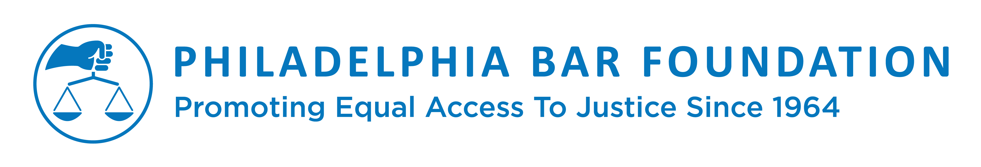
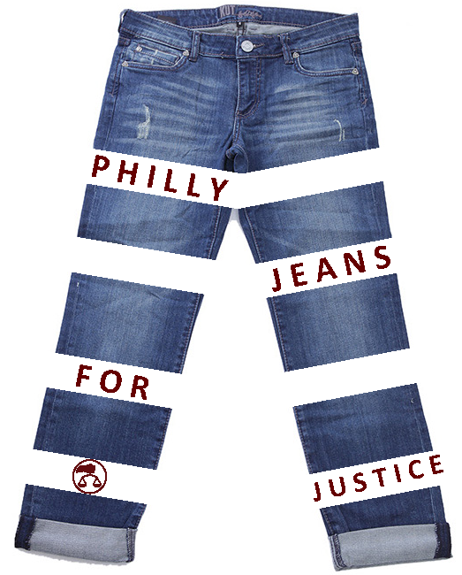
Philly Jeans for Justice Sample Email & Social Media Posts

Instructions: Drum up the excitement and participation from your office. Use this model template with sample email and social media posts to send to your colleagues. All templates are customizable, so have fun with it! Thank you for your support!
Model Email (Send to Colleagues in Your Office)

Dear Staff:

Our office has decided to participate in the Philadelphia Bar Foundation’s Philly Jeans for Justice Campaign. On [insert participation date here] we will hold a “Go Casual Day” supporting the Foundation’s grants and other assistance to a wide range of legal aid nonprofits in Philly. The firm or company with the most participants or money raised will receive a SPECIAL PRIZE!

Our team captain is [insert team captain name/contact information here.]

It is easy for you to sign up and “pay” to wear denim for a day. Simply go online and securely donate $5 (OR MORE!) to the Bar Foundation. The Foundation will coordinate with the team captain from our office and your donation amount will be confidential. Instead of donating online, you can give $5, or another donation amount, directly to our team captain and put your name on the sign-up sheet.

On the day of our event, please make sure you post to social media to spread this campaign citywide! Any questions? Reach out to our team captain or Adrienne Brown, Marketing and Development Coordinator for the Philadelphia Bar Foundation at 215-238-6322 or abrown@philabarfoundation.org. Let’s join together to fight for equal access to justice!

Many thanks,

Twitter

We’re proud to support @PhilaBarFdn for #PhillyJeansforJustice! [Insert Picture]

We, along w/ the @PhilaBarFdn, have made a commitment for fight for access to justice #PhillyJeansforJustice [Insert Picture]

Facebook

We are proud to support the @PhiladelphiaBarFoundation for their #PhillyJeansforJustice Campaign raising crucial funding for its grants and other assistance to a wide range of legal aid nonprofits in Philly! [insert picture]

We’re making a commitment to fight for equal access to justice for all with the @PhiladelphiaBarFoundation in support of their #PhillyJeansforJustice Campaign to raise crucial funding for its grants and other assistance to a wide range of legal aid nonprofits in Philly! [insert picture]

